**Product Details Portal**

**Screenshot**

**Product.html**

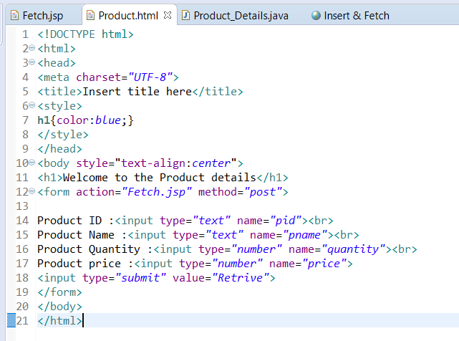

**Fetch.jsp**

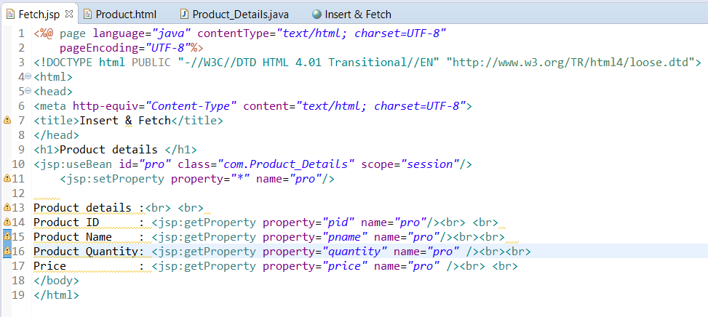

**Product_Details.java**

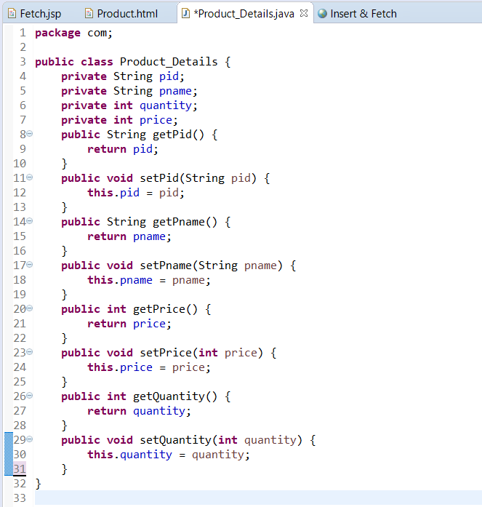

**OUTPUT**

